

**NAME-** Sunita Parida

TABLE OF CONTENTS

1. Design Document.....................................................3
2. Program specification...............................................8
3. Requirement study...................................................16

3.1 Introduction...............................................17

3.2 Objective...................................................18

3.3 Scope.........................................................19

3.4 Benefits......................................................20

3.5 DFD………………………………………………………...21

3.6 UseCase…………………………………………………..25

3.7 ERD…………………………………………………………..27

3.8 FlowChart………………………………………………...29

4. Functional study............................................................31

4.1. Functional Requirement...............................32

**DESIGN DOCUMENT**

**TABLE NAME**- COLLEGE_DETAILS

**PK**- College-ID

**DESCRIPTION**- College Details

|  |  |  |  |  |
| --- | --- | --- | --- | --- |
| Field Name | Data Type | NULL? | KEY | Description |
| Sl_NO | INT | N |  | Serial No |
| College_ID | VARCHAR(10) | N | Pk | College Id |
| College_Name | VARCHAR(40) | N |  | College Name |
| Contact_Details | VARCHAR(10) | N |  | Mobile number |
| Email | VARCHAR(50) | N |  | College Email |
| Request | VARCHAR(1) | N |  | Request |
| College_Address | VARCHAR(80) | N |  | College Address |
| Password | VARCHAR(10) | N |  | Password |

**TABLE NAME-** Company_Details

**PK-** Company -ID

**DESCRIPTION-** Company information

|  |  |  |  |  |
| --- | --- | --- | --- | --- |
| Field Name | Data Type | NULL? | KEY | Description |
| Sl_NO | INT | N |  | Serial No |
| Company ID | VARCHAR(20) | N | Pk | Company Id |
| User_Name | VARCHAR(20) | N |  | User Name |
| Company_Name | VARCHAR(20) | N |  | Company Name |
| Email | VARCHAR(50) | N |  | Company Email |
| Contact_Details | VARCHAR(10) | N |  | Contact Details |
| Company_Address | VARCHAR(50) | N |  | Company Address |
| Password | VARCHAR(10) | N |  | Password |

**TABLE NAME-** STUDENT_DETAILS

**PK-** REGISTRATION_NUMBER

**DESCRIPTION-** Student information

|  |  |  |  |  |
| --- | --- | --- | --- | --- |
| Field Name | Data Type | NULL? | KEY | Description |
| Sl_NO | INT | N |  | Serial No |
| Student_Name | VARCHAR(20) | N |  | Student Name |
| Registration_Number | VARCHAR(20) | N | pk | Registration Number |
| Phone_Number | VARCHAR(10) | N |  | Phone Number |
| DOB | Date | N |  | Date Of Birth |
| Email | VARCHAR(50) | N |  | Email Id |
| Highest_Qualification | VARCHAR(20) | N |  | Highest Qualification |
| YEAR_OF_PASSOUT | VARCHAR(10) | N |  | Year Of Pass Out |
| Degree_Percentage | VARCHAR(10) | N |  | Degree Percentage |
| Graduation | VARCHAR(10) | N |  | Graduation Details |
| Graduation_Percentage | VARCHAR(10) | N |  | Graduation_Percentage |
| CHSE | VARCHAR(10) | N |  | CHSE Details |
| Percentage_CHSE | VARCHAR(10) | N |  | CHSE Percentage |
| HSC | VARCHAR(50) | N |  | HSC DETAILS |
| HSC_PERCENTAGE | VARCHAR(10) | N |  | HSC PERCENTAGE |
| CV | BLOB | N |  | CV |
| College_Name | VARCHAR(30) | N |  | College Name |
| Student_Address | VARCHAR(50) | N |  | Student Address Details |
| Password | VARCHAR(10) | N |  | Password |
| Approve | VARCHAR(1) | 0 |  | Approve |

**TABLE NAME-** VACANCY

**PK-** Company -ID

**DESCRIPTION-** Post information

|  |  |  |  |  |
| --- | --- | --- | --- | --- |
| Field Name | Data Type | NULL? | KEY | Description |
| Sl_NO | INT | N |  | Serial No |
| Company -ID | VARCHAR(20) | N | pk | Company ID |
| Company_Name | VARCHAR(20) | N |  | Company Name |
| Job_Profile | VARCHAR(30) | N |  | Job Profile |
| Eligible_Criteria | VARCHAR(50) | N |  | Eligible Criteria |
| Salary | INT | N |  | Salary |
| Bond | VARCHAR(50) | N |  | Bond Details(if any) |
| Email | VARCHAR(50) | N |  | Email Id |
| Contact_Details | VARCHAR(10) | N |  | Contact Details |
| Company_Address | VARCHAR(50) | N |  | Company Address |

**PROGRAM SPECIFICATION**

**Company Login**

|  |  |
| --- | --- |
| **Screen Name** | Login |
| **Module** | Company |
| **Menu Reference** | Login |
| **Dependency on Module** | NA |
| **Inputs** | |
| * User Name * Password | |
| **Validation** | |
| * Username should not blank. * Password should contain at least character. * Invalid Username or password. | |
| **Process Logic** | |
|  | |
| **Output** | |
| * Redirect to Company Dashboard | |

|  |  |
| --- | --- |
| **Module** | College |
| **Menu Reference** | Login |
| **Dependency on Module** | NA |
| **Inputs** | |
| * College Id * Password | |
| **Validation** | |
| * Username should not blank. * Password should. * Invalid Username or password. | |
| **Process Logic** | |
|  | |
| **Output** | |
| * Redirect to College Dashboard | |

**College Login**

|  |  |
| --- | --- |
| **Module** | Student |
| **Menu Reference** | Login |
| **Dependency on Module** | NA |
| **Inputs** | |
| * Registration Number * Password | |
| **Validation** | |
| * Username should not blank. * Password should. * Invalid Username or password. | |
| **Process Logic** | |
|  | |
| **Output** | |
| * Redirect to Student Dashboard | |

**Student Login**

|  |
| --- |
| * Company ID * User_Name * Company Name * Email * Contact_Details * Company_Address * Password |
| **Validation** |
| * Username should not blank. * All fields are mandatory (*) * User already exist |
| **Process Logic** |
|  |
| **Output** |
| * Data save Successfully and Redirect to Company Login Page |

**Company Registration**

|  |
| --- |
| **Inputs** |

**Post Vacancy**

|  |  |
| --- | --- |
| **Module** | Company |
| **Menu Reference** |  |
| **Dependency on Module** | Login |
| **Inputs** | |
| * Company -ID * Company_Name * Job_Profile * Eligible_Criteria * Salary * Bond * Email * Contact_Details * Company_Address | |
| **Validation** | |
| * Job Profile should not blank. * All fields are mandatory (*) | |
| **Process Logic** | |
|  | |
| **Output** | |
| * Data save Successfully and Redirect to Company Home Page | |

|  |
| --- |
| **Inputs** |
| * College_ID * College_Name * Contact_Details * Email * College_Address |
| **Validation** |
| * All fields are mandatory (*) |
| **Process Logic** |
|  |
| **Output** |
| * Data save Successfully and Redirect to Company Login Page |

**College Registration**

|  |
| --- |
| **Inputs** |
| * Student_Name * Registration_Number * Phone_Number * DOB * Email * Highest_Qualification * YEAR_OF_PASSOUT * Degree_Percentage * Graduation * Graduation_Percentage * CHSE * Percentage_CHSE * HSC * HSC_PERCENTAGE * CV * College_Name * Student_Address * Password |
| **Validation** |
| * All fields are mandatory (*) |
| **Process Logic** |
|  |
| **Output** |
| * Data save Successfully and Redirect to Student Login Page |

**Student Registration**

**REQUIREMENT STUDY**

**INTRODUCTION**

A college campus recruitment system that consists of a student login, company login and an College login. The project is beneficial for college students, various companies visiting the campus for recruitment and even the college placement officer. The software system allows the students to create their profiles and upload all their details including their marks onto the system. college placement officer can check each student details and can remove faulty accounts. The system also consists of a company login where various companies visiting the college can view a list of students in that college and also their respective resumes. The software system allows students to view a list of companies who have posted for vacancy. The admin has overall rights over the system and can moderate and delete any details not pertaining to college placement rules. The system handles student as well as company data and efficiently displays all this data to respective sides. The online campus selection software work at college or university. The College invited to recruiter/company for register in this system and help to get employee easily as per their qualification and requirements. Other hand college has all the student data submitted in this system so student can get easily job. The system is a mutual place for student and company. The online campus selection system helps student to get job and company to get employee.

We can use Campus Selection system for University and any Companies. It is developed for smooth working of HR Department.  Universities and companies can get benefited through this system. This Software is fully integrated with Student and Company Relationship Management and developed in a manner that is easily manageable, time and cost saving that shows relieving one from manual works. Online Campus Selection provides automated technical screening, intellectual evaluation, electronic mail integration to conduct recruitment. This feature’s helps in many ways like saving cost, time and paper work, this shows the paperless environment, unlimited Custom and reports.

**OBJECTIVE**

Development of rich web based Campus Selection System for Universities and any Companies. Online Campus Selection System is developed for smooth working of Human Resource Departments. Universities and companies can get benefited through this system. This Software is fully integrated with Student and Company Relationship Management and developed in a manner that is easily manageable, time and cost saving that shows relieving one from manual works. Online Campus Selection provides automated technical screening, intellectual evaluation, electronic mail integration to conduct recruitment. This feature’s helps in many ways like saving cost, time and paper work, this shows the paperless environment, unlimited Custom and reports.

The major objective of campus placement is to identify the talented and qualified professionals before they complete their education. This process reduces the time for an industry to pick the candidates according to their need. It is a cumbersome activity and hence majority of the companies find it difficult to trace the right talent. **Many students do not understand the importance of placement training that is being imparted, whether it is an aptitude training or soft skills.**They show the least interest in this due to various factors viz., projects, assignments or more of activities loaded by the colleges as part of their curriculum thinking that it is not useful. It is the responsibility of the companies training on placement to make the students equipped on all aspects of career development along with creating a very good impact in them which makes them feel every minute they spend in the placement training session is worth being there and will help them in getting placed in their dream companies.

**SCOPE**

This system automates the Selection process activities that the HR Department has to perform prior to and after the actual act of selecting the students. This system helps in various ways such as saving time and cost of selecting Students and companies. That set of concepts is used to build a system for easily Communication between students and companies and company can get required eligible students.

**BENEFITS**

* The companies will be benefited from getting wide choice of candidates to select for different job posts. Companies can select the right and talented candidate from a vast pool of young applicants within a limited time. On the other hand, students have the advantage of getting a good job according to their qualification level even before the completion of their academic course in college.
* Campus recruitment helps in saving time and efforts of the companies. The entire campus recruitment process from a college is not a tedious toil. It prevents the occurrence of unusual expenditures related to recruitment process such as advertisement, initial screening, and final selection procedures etc. This in turn turns to be useful in reduced manpower effort and time as well.
* An organization through effective campus recruitment finds an opportunity to establish a link with the next batch of students. This in turn paves way to serve the future and long term recruitment needs of the company. Students participating in internships and summer training programs may have direct recruitment to different job positions offered by the company.
* Campus recruitment helps in increased selection ratio. More number of quality candidates can be selected through this recruitment process.
* The organizations can built up more company loyalty through campus selection process. Fresh and talented graduates will work more closely with their first company. Hence, this in a way will increase the brand loyalty among different applicants.

**DFd (Data Flow Diagram)**

Data-flow diagram is a model that shows the graphical flow of data through an information system, the relationships among the data flows, and how data come to be stored at specific locations. Data-flow diagrams also show the processes that change or transform data. Data-flow diagram focuses on the movement of data between processes, called process models.

**Lvl 0 DFD :-**

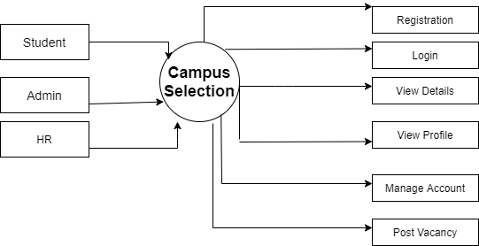

**Figure:-** Level 0 DFD For Campus Selection

**Lvl 1 DFD :-**

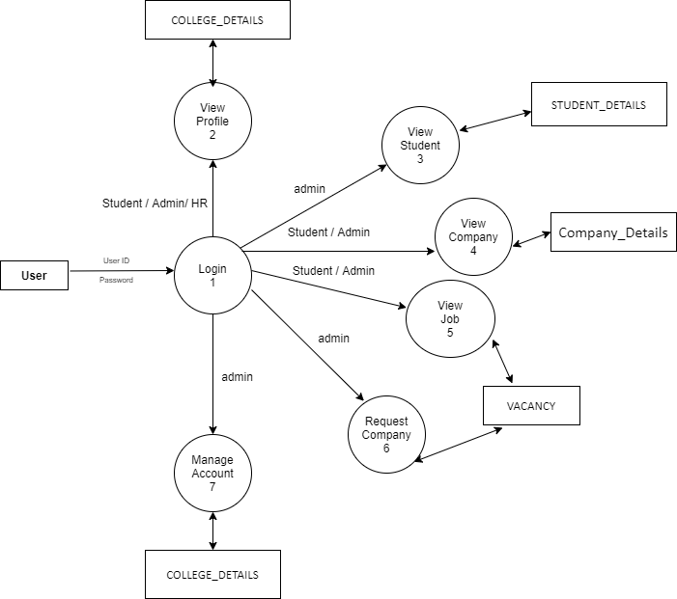

**Figure:-** Level 1 DFD For Campus Selection

**Lvl 2 DFD :-**

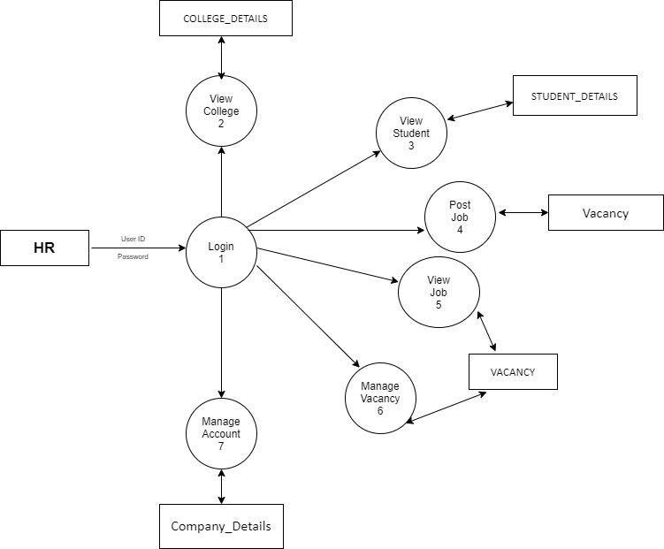

**Figure:-** Level 2 DFD For Campus Selection

**UseCase Diagram**

39

The Use case diagram is a graphic that is used to define the core elements and processes that make up a system. The key elements are termed as "admin", “student” and the processes are called "use cases." It shows which actors interact with each use case.

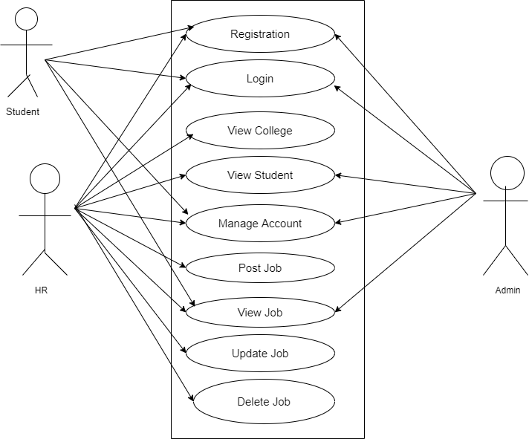

**Figure:-** UseCase Diagram For Campus Selection

**Entity Relationship Diagram**

An entity-relationship diagram is a data modeling technique that creates a graphical representation of the entities, and the relationships between entities, within an information system. It depicts a visual representation of different data using conventions that describe how these data are related to each other. It has three notations which are: Entity, Relationship and Cardinality.

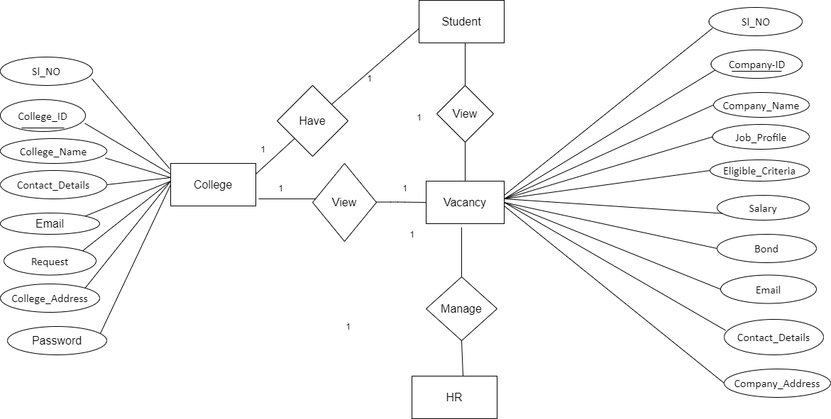

**Figure:-** Entity Relationship Diagram For Campus Selection

**Flow Chart**

A **flowchart** is a type of [diagram](https://en.wikipedia.org/wiki/Diagram) that represents a [workflow](https://en.wikipedia.org/wiki/Workflow) or [process](https://en.wikipedia.org/wiki/Process). A flowchart can also be defined as a diagrammatic representation of an [algorithm](https://en.wikipedia.org/wiki/Algorithm), a step-by-step approach to solving a task.

The flowchart shows the steps as boxes of various kinds, and their order by connecting the boxes with arrows. This diagrammatic representation illustrates a solution model to a given [problem](https://en.wikipedia.org/wiki/Problem_solving). Flowcharts are used in analyzing, designing, documenting or managing a process or program in various fields.[[](https://en.wikipedia.org/wiki/Flowchart#cite_note-SSEV-1)

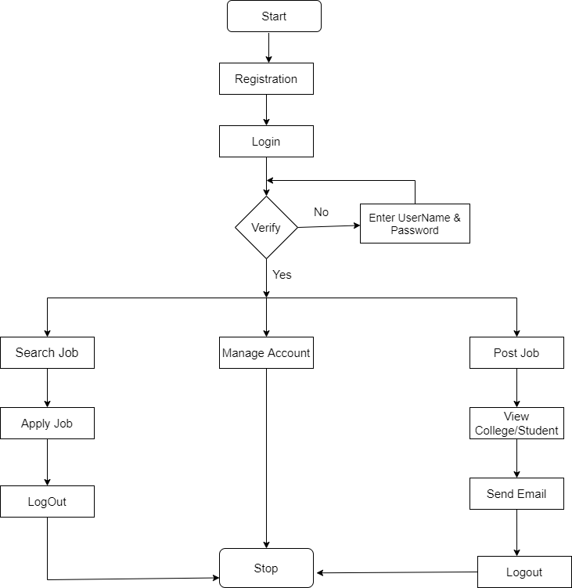

**Figure:-** FlowChart For Campus Selection

**FUNCTIONAL STUDY**

**FUNCTIONAL REQUIREMENT**

* **Authentication**
* **Login-** The user can login with his/her username and password.
* **Logout-** The user can log out from the system.
* **Login failure-** If the user does not exist in the database or if any wrong input.
* **Authorization**
* **User role check**- After logging in, the user role will be checked from the database and the user interface will be displayed according to their role.
* **Process Data**
* **Display-** User with defined roles can display the content of the database. Being more specific, Student can only view his/her personal information. Admin can not only see his/her personal information but also Student’s information who are under his/her College. HR can display their personal information and all College List and Candidate List.
* **Post-** HR can post job details.
* **Edit-** A user with Student can edit his/her specific personal information. Admin can only edit College personal information that is under his/her coverage. HR can edit all information and the job details.
* **Search-** Student/Admin can search job with Company Details. But HR is search the collge details and student details of the respective college’s.
* **Request job/Approved**
* **Request job** - The admin can be able to request the Company(HR).
* **Approved –**those college’s requsted to the company then the HR can show the requsted college’s list and then give approve. After Approved HR send an Email to the college placement.